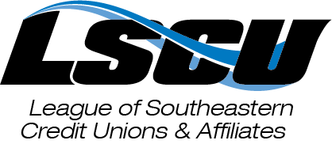
League Report
July 2022

Executive Summary:
LSCU successfully supported a number of candidates in Alabama and Georgia’s June 21 Primary Runoff Elections. The focus now shifts to Florida’s August 23 Primary Election, where many credit union friendly candidates will be on the ballot. The full list of LSCU-endorsed and PAC-supported candidates can be found HERE. This month we also enjoyed spending time with many of you during the 2022 Southeast Credit Union Conference & Expo where we saw historic attendance with over 1,000 attendees and exhibitors and created valuable networking opportunities during the largest annual gathering of credit unions in the Southeast.
Advocacy:
State Legislative Updates:
83% of ACULAC-supported candidates won their races during Alabama’s June 21 Primary Runoff Election. Because of the makeup of Alabama’s districts, the primary elections decided the fate of most ACULAC-supported candidates. Unofficial election night results in Alabama can be found HERE. We now point our political advocacy efforts toward a handful of “up in the air” races in the General Election and ensuring those ACULAC-supported candidates who won their primaries are also successful in November.
Florida’s advocacy team spent much of June interviewing candidates prior to the June 17th qualifying deadline. While there were a few surprises around the state, most candidates stayed in the seats they planned to run in throughout the year. We’ve funded many credit union-friendly candidates and will continue to coordinate meetings with our local volunteers as we work to get-out-the-vote prior to the August 23rd primary election.
In Georgia we spent most of the last month preparing for the June 21st Primary Runoff Election. We traveled the state, meeting with candidates who advanced to the runoff from the primary, while also increasing GA CUPAC support to those who we had already supported ahead of the May 24th Primary. Of the GA CUPAC-supported candidates in the Runoff, LSCU had 100% success rate. Unofficial election night results in Georgia can be found HERE.
Federal Legislative Update:
In Alabama and Georgia, we worked to successfully elect LSCU-endorsed candidates Katie Britt (U.S. Senate in Alabama), Dale Strong (AL-05), Rich McCormick (GA-06), and Mike Collins (GA-10) in the June 21 Runoff Elections.
During the week of June 20, LSCU met with key federal offices in D.C., including Senator Marco Rubio (R-FL), members of leadership, and relevant committee members. Meetings garnered support for and centered around H.R. 6889, the Credit Union Board Modernization Act, data and consumer privacy, cannabis banking, financial literacy, and more.
As Senate markups of the National Defense Authorization Act continue, LSCU has aggressively defended credit union access to military bases amid efforts by the Bankers Association to gain rent-free access to bases. Conversations are expected to continue into the August recess. Additionally, credit unions successfully worked to block an attempt by Rep. Carolyn Maloney (NY-12) to regulate overdraft fees. The legislation was pulled from markup on June 22.
Regulatory Advocacy:
LSCU is currently in the letter writing process for the annual NCUA Regulatory Review and the No-Action Letter Process to FinCEN. Both letters are due in August.
We recently met with the Georgia Department of Revenue regarding the implementation of a rule that requires financial institutions to run a delinquent taxpayer list against the institution’s membership. The discussion centered around the contract that includes specific language on how the data is to be managed. Because credit unions are already required to follow Gramm-Leach-Bliley Act and other privacy rules we feel this is an overreach on their part. We are optimistic that we will come to an agreement that will not be detrimental to credit unions as they have already modified the contract based on other suggestions we have made.
Grassroots Advocacy:
LSCU’s grassroots efforts have focused on vetting and supporting candidates. In Florida, the advocacy team participated in candidate interviews as members of the Chamber of Commerce Political Institute. In Alabama and Georgia, we have focused on facilitating introductory conversations with credit unions in newly elected official’s districts. If you are interested in engaging, please contact Sydney Rubin Seral at Sydney.Rubin@lscu.coop.
PAC Fundraising:
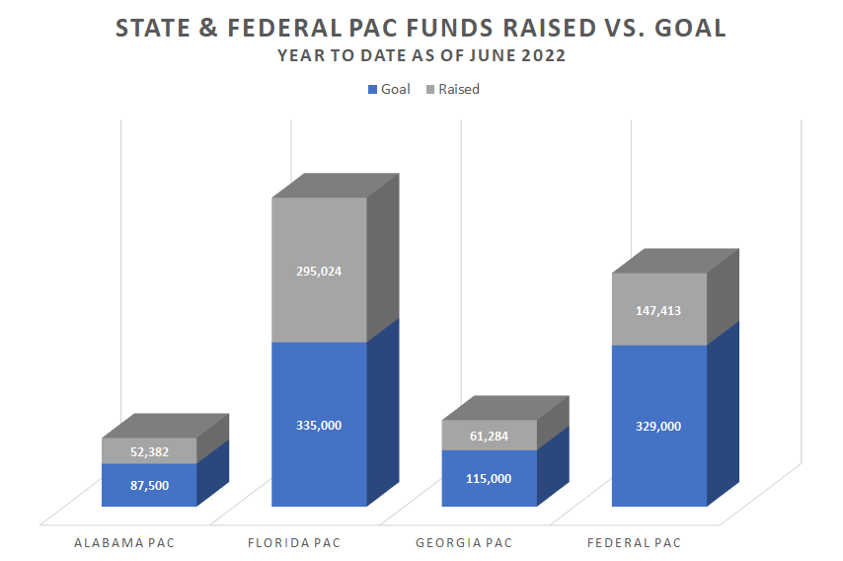
In the 2022 Election Cycle, we have disbursed State PAC contributions as follows: $144,288 in Alabama, $267,000 in Florida, and $353,473 in Georgia. Additionally, LSCU has disbursed $173,500 to federal candidates thus far this cycle.
The LSCU held our signature fundraising events in-conjunction with SCUCE: the Silent Auction and Advocacy Luncheon. The two events raised a total of $44,779 for LSCU PACs with $34,419 coming from the Silent Auction and $8,360 from the Advocacy Luncheon. Thank you to our member credit unions and conference exhibitors for supporting LSCU PACs at SCUCE and making our fundraisers a huge success!
Compliance Services:
To prepare for hurricane season we have updated the resources available to our credit unions that can be found on the Foundation Disaster page on the LSCU website.
Gulf Coast FCU signed up for RecoveryPro along with the shared compliance program for implementation and a tabletop exercise.
Education & Training:
We welcomed a record number of credit union attendees and exhibitors to Orlando for the Southeast Credit Union Conference & Expo from June 15 – 17. Over 1,000 attendees networked, celebrated award winners, attended educational sessions, and roundtable events.
On June 14, LSCU hosted the first LSCU Council Conference. Over 90 attendees participated in a general session, breakout sessions, and roundtable meetings for each of the eight councils. Reviews were very positive, attendees found the sessions valuable, and this event increased awareness of the council program and has helped to grow additional members.
Two new virtual training opportunities were opened for registration in June: Virtual Branch Manager Training on August 23 and 24 and Virtual Employee Engagement on October 25.
Communications:
LSCU was excited to honor 19 deserving individuals and credit unions at this year’s SCUCE Awards Ceremony. Videos from the ceremony can be found here and pictures from the conference can be found here.
The portal for the CUNA Awards closed in early June, and we look forward to seeing credit unions from Alabama, Florida, and Georgia advance to the national level.
Member Engagement:
LSCU welcomed two non-affiliated credit unions to SCUCE in Orlando, including AdventHealth Credit Union and Fairwinds Credit Union. Follow-up efforts have commenced in hopes of welcoming these credit unions back as LSCU affiliates.
LSCU is excited to launch customized engagement sessions and new staff orientations to provide all credit unions and their teams with resources to maximize membership. Please contact Alisha Stair at Alisha.Stair@lscu.coop to participate in the pilot program.
SECUF:
The Alabama and Georgia Community Spark Scholarship awarded the first two scholarships to Terrell Jones and Henderson Rosser who will be attending Morehouse College and Tuskegee University in the fall. The Florida Community Spark Project is on track with data collection and curriculum building for the Credit Union Member Serice Specialist training program.
The enhanced Financial Counseling Certification Program registration is currently open. Not only will individuals who complete the program earn their Certified Credit Union Financial Counselor designation, they will receive virtual training designed to help apply lessons learned into real-world application, inclusion in the Online FiCEP Community, and quarterly facilitated online peer networking and educational meetings. Register here.

