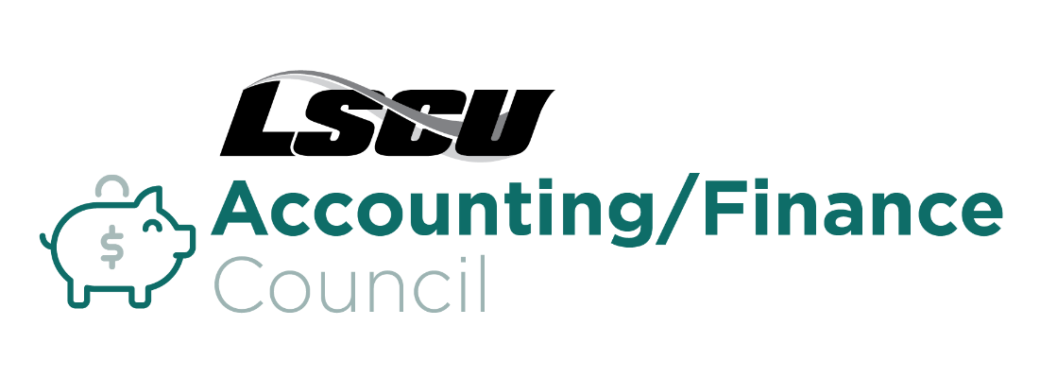
Thursday, April 13, 2023
9:00 a.m. – 12:00 p.m. EST
Zoom Meeting

9:00 a.m. – 9:15 a.m. Welcome / Opening Remarks

9:15 a.m. – 10:15 a.m. NCUA Supervisory IRR test and Liquidity

The NCUA IRR testing and Liquidity will be the focus. The current economy weaves its way into the IRR and Liquidity section so it will probably not have a standalone section.

The NCUA just published the 2023 exam priorities. The top two were interest rate risk and liquidity.

Trey Rudder, Vice President of Strategic Balance Sheet Management, Corporate America Credit Union

Mr. Rudder has a Bachelor of Science in Industrial Management degree from Georgia Institute of Technology and a Master of Science in Finance degree from Georgia State University. Trey joined the Corporate America team in 2016. Trey Rudder is currently responsible for the Strategic Balance Sheet Management Department (SBSM) at Corporate America Credit Union. The department has two areas of focus. One is the responsibility for measuring and monitoring Interest Rate Risk for Corporate America. The other is developing balance sheet solutions for member credit unions which includes ALM, liquidity, strategies, and training. The SBSM department continues to develop timely ALM solutions and help member credit unions use the ALM information in their strategic decision-making process. Trey has over 20 years balance sheet management experience with both corporate credit unions and regional banks such as Southeast Corporate Credit Union, AloStar Bank of Commerce, AmSouth, and BBVA Compass Bank.

10:15 a.m. – 10:30 a.m. Break

10:30 a.m. – 11:30 a.m. Demystifying the Employee Retention Tax Credit

Educational session on the Employee Retention Tax Credit. Misconceptions, credit union potential eligibility, calculations, and filing timelines. Thank you for the opportunity and I’m happy to answer any further questions.

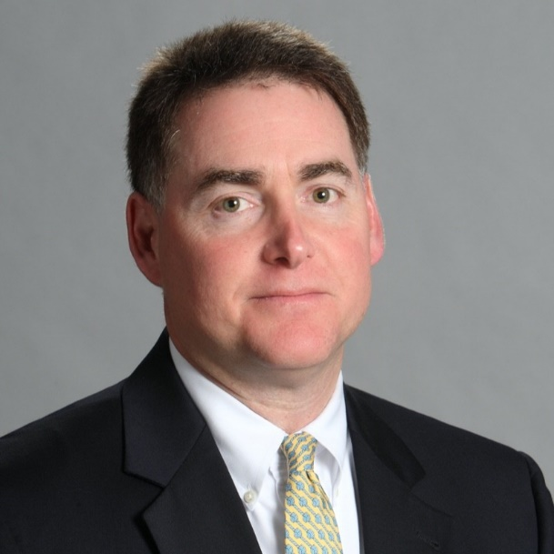
Bradley Marcus, Executive Vice President, Cares Act Bank Alliances, Synergi Partners

Brad Marcus is well known in the banking arena, having spent almost 40 years in the industry. Most recently, Brad serves as Executive Vice President- Cares Act Bank Alliances at Synergi Partners. Synergi Partners, is the most knowledgeable firm in their space with an executive team of veteran tax credit experts that possess more than 150 years of combined know-how. Synergi Partners is focused on providing solutions to companies to help build productivity and profitability.
Brad's interests in tax credits spawned from his many years in economic development and volunteer work for the American Red Cross where he served as chairman of the American Red Cross- Georgia Chapter. He specializes in tax credit applications for banks and building bank alliances to assist banks in providing strategic financial solutions for their customers.
Brad recently retired from Wells Fargo/Wachovia as Executive Vice President of Commercial Banking- Georgia Division with over 30 years in banking leadership experience. He is now focused on establishing Cares Act partnerships with banks as they provide creditable solutions, including employee retention tax credits, to meet the financial needs of their customers.
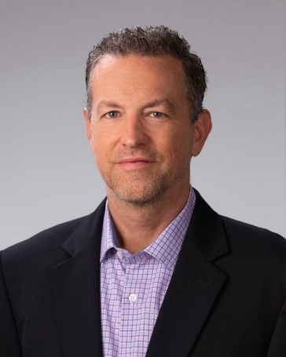
Tom Godfrey, National Sales Manager, Synergi Partners

Experienced sales consultant with a history of top tier success in the information technology & services industry. Skilled in workforce management strategies, networking & guiding a prospective client audience through an evaluation journey.

11:30 a.m. – 12:00 p.m. Open roundtable Discussion, Q&A, Networking
12:00 p.m. Adjourn

